CIS7 Unit 12 Lab: Programming Cryptography in C++
In this lab activity, we will program Caesar Cipher and Linear Shift Cipher in C++. Refer to Chapter 5 content and notes for Caesar Cipher and Linear Shift Cipher details.
The encryption can be represented using modular arithmetic by first transforming the letters into numbers, according to the scheme, A = 0, B = 1,…, Z = 25. Encryption of a letter by a shift n can be described mathematically as.
Encryption of a letter by a shift n can be described mathematically as:
(Encryption Phase with shift n)
E_{n}(x) = (x + n) mod 26
(Decryption Phase with shift n)
D_{n}(x) = (x - n) mod 26
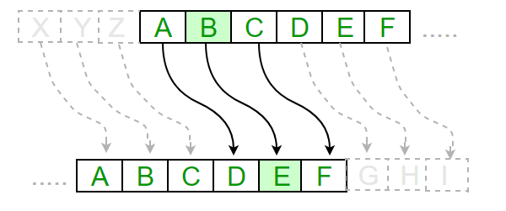
Complete the following tasks and answer the questions:

Example 2: Caesar Cipher

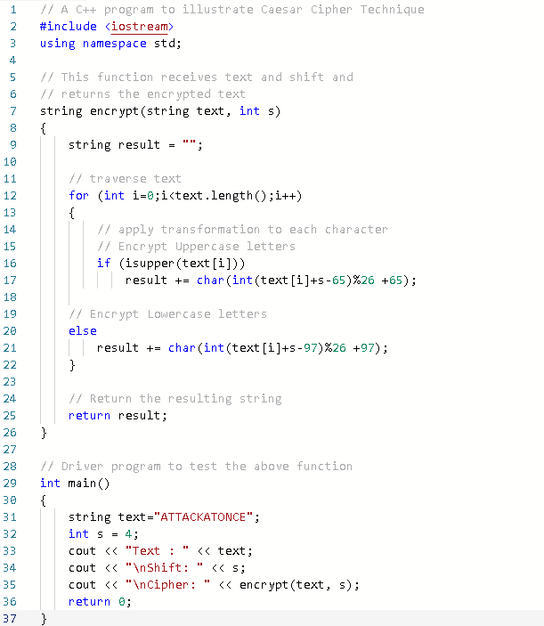
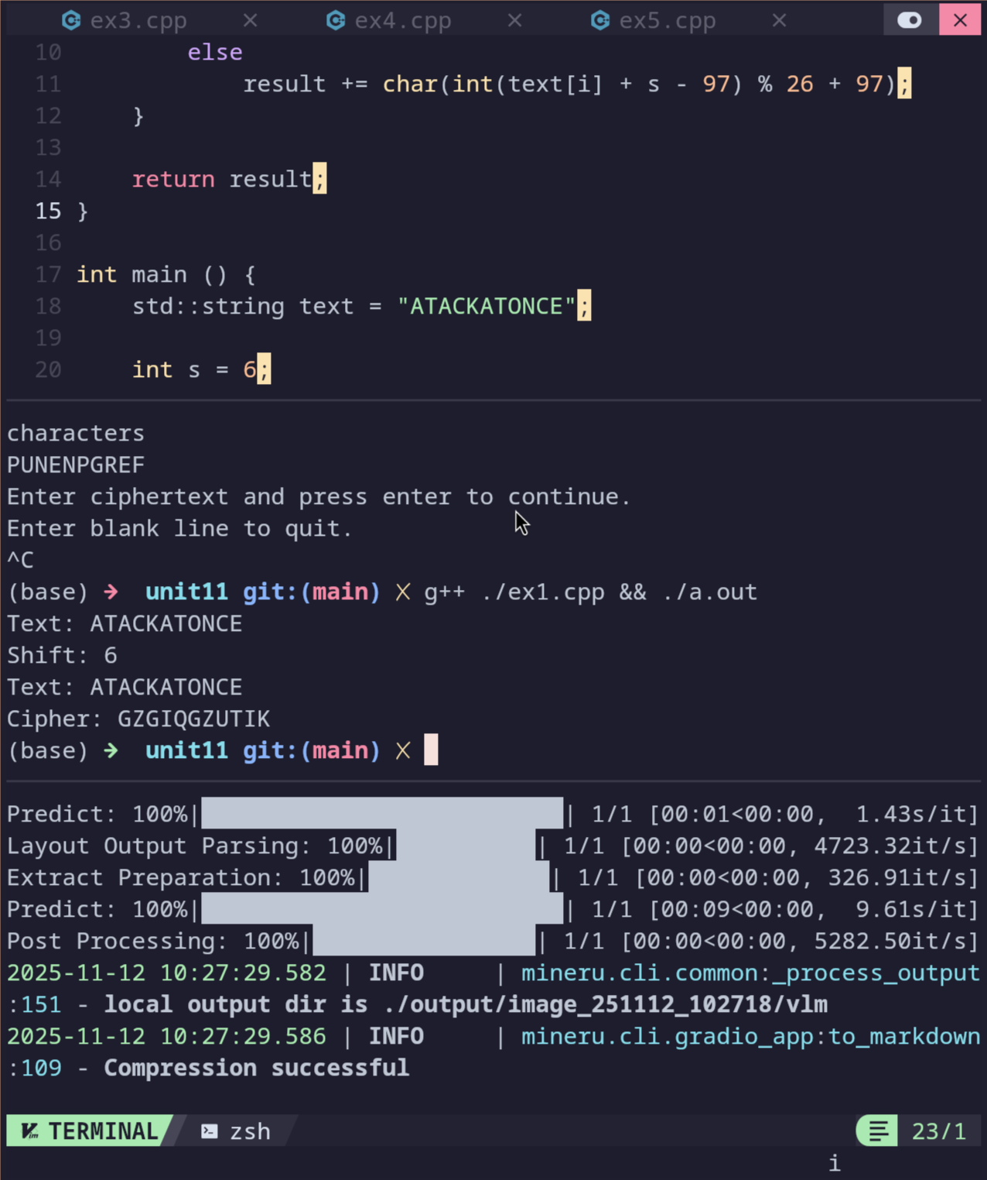
- Input the Example 1 program into an IDE. Run the program and answer the following questions:
- How many characters are shifted in this program to cipher the text string?
S = 4

- Use the below table, input the shifted character equivalence to verify whether the program output is accurate.
A | B | C | D | E | F | G | H | I | J | K | L | M | N | O | P | Q | R | S | T | U | V | W | X | Y | Z
E | F | G | H | I | J | K | L | M | N | O | P | Q | R | S | T | U | V | W | X | Y | Z | A | B | C | D

- Edit the program to contain a different shift-value and plain-text string, then run the program. Provide screen capture containing program code and output. What is the shift-value? What is the plaintext string? What is the output?

- Identify the section of the code that contains the encryption mechanism in the program. Provide a brief explanation on the programming functionality of this section.
The function called encrypt contains the cipher code. It simply converts the every character in the string to it the number position of that character in the alphabet, adds the shift, then modulates it so all values stay within the alphabet.

Example 2: Caesar Shift with User Input

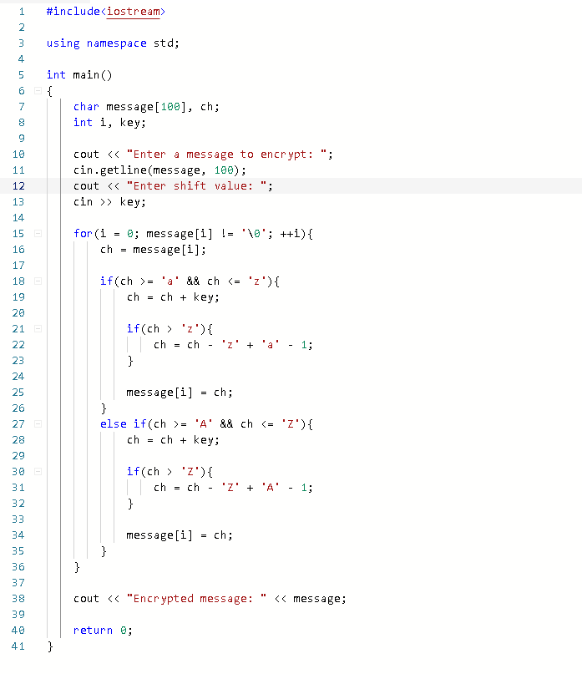
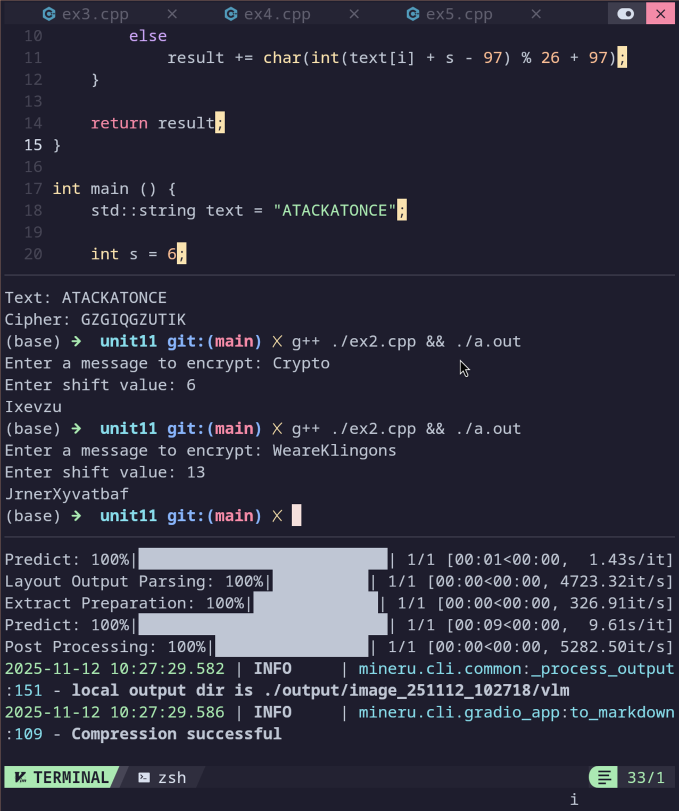
- Input the following program into an IDE, run the program and answer the following questions:
- Given the message: WeareKlingons. Use shift value of 13. Verify whether the program output is accurate through the illustration of shifting characters manually.
JrterXyvatbaf
- Review the program code and explain how Shift Cipher is integrated in the program.
In this version of the program the function encrypt is removed and it is replaced with a more verbose, less efficient, block of code where instead of using a modulo and discrete ascii values for getting the characters index number in the alphabet.
- Compare Example 2 to Example 1 program, explain the differences between the programs.
Like previously mentioned it uses and if instead of if a modulo.

Example 3: Decryption Shift Cipher
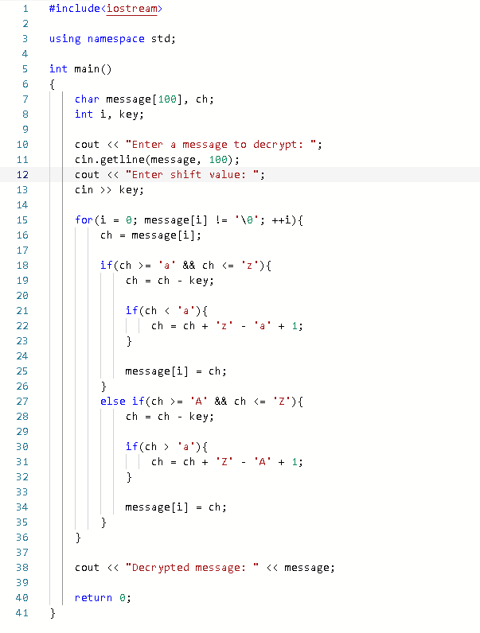
- Input the following program into IDE, run the program to test decryption and answer the following questions:
- Determine the output using the alphabet characters substitution method when using the message ‘Crypto’ shifting 6 places.
Ixevzu
- Explain the program decryption functionality.
It is supposed to do essentially the same thing as the last two examples, but with a negative key.

- Compare this program to the encryption program in Exercise 2, what are the primary differences and similarities between the programs?

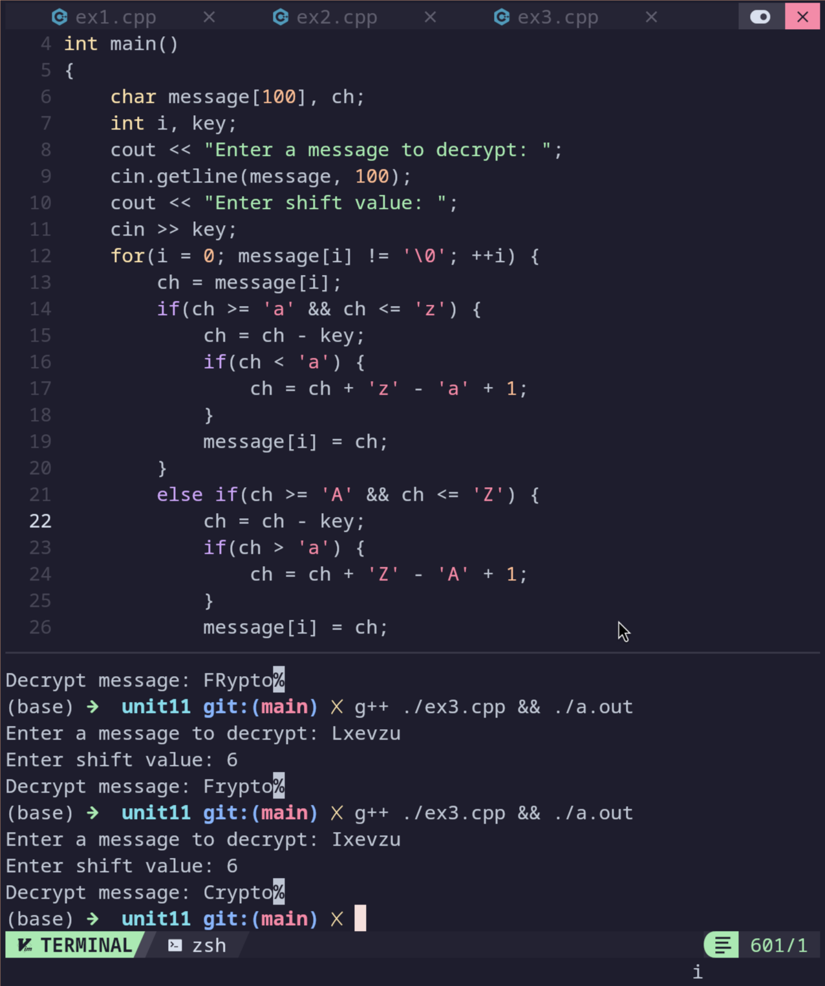

Example 4: Encryption Shift String
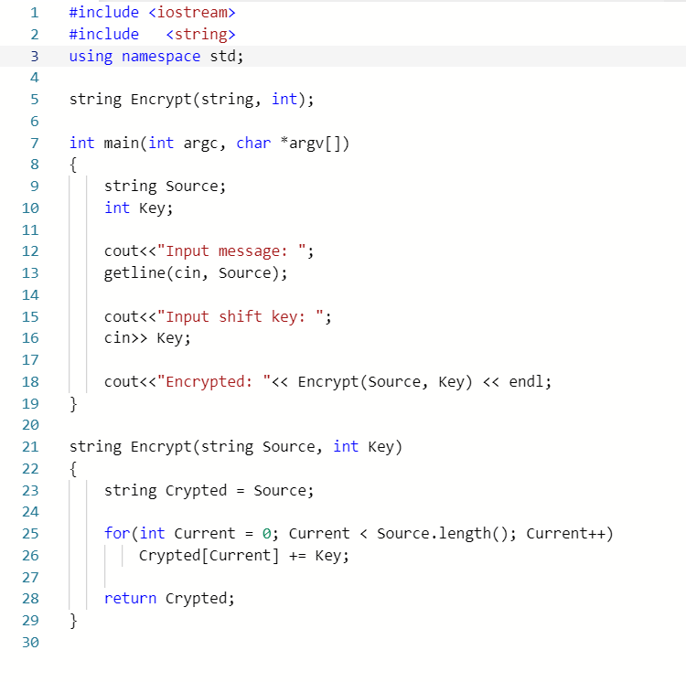
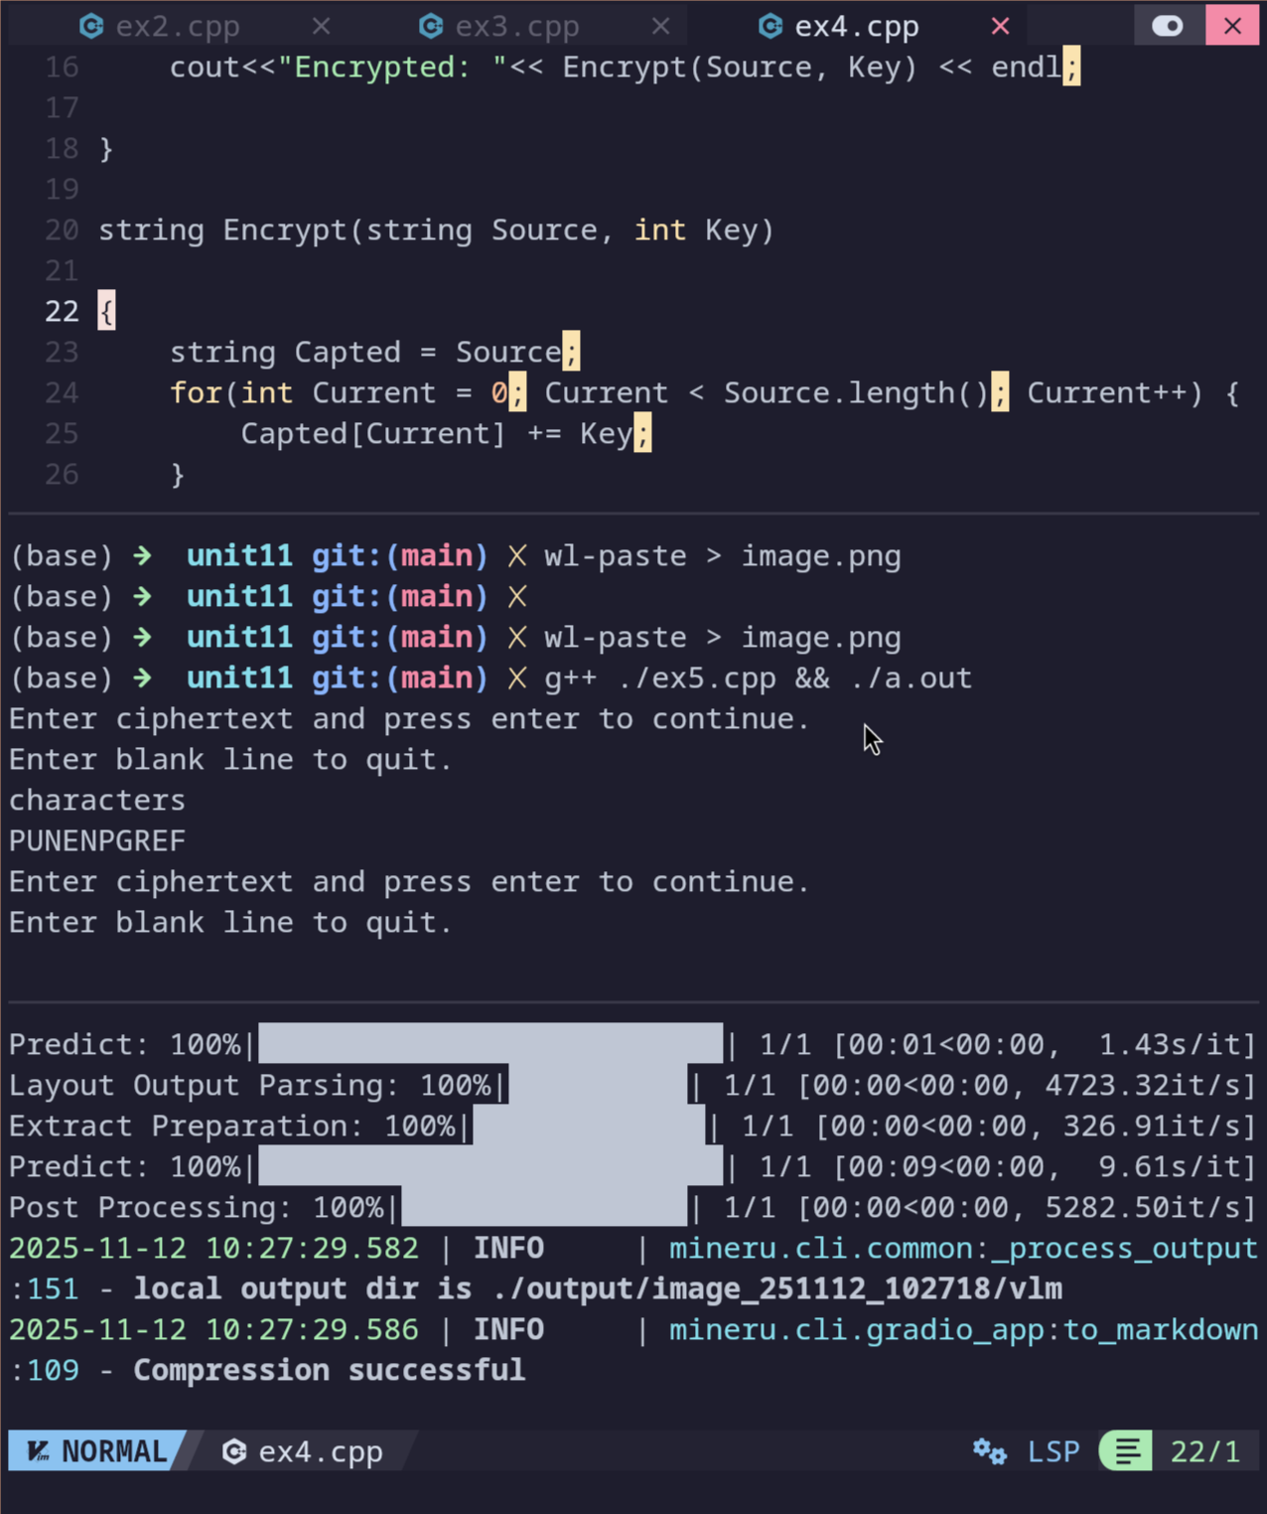
- Input the following program in IDE, test the program and answer the following questions:

- Use shift cipher character substitution method to determine the output for ‘substitution’ when the shifting 5 places.
xzgxynyzynts
- Review the program to identify the section that contains the primary functionality of shift cipher. Explain how the shift cipher is integrated in this program.
This program doesn’t do wrapping on the characters. It just adds the key to the character.

- Compare this program to the Example 1 and Example 2 programs, what are the differences and similarities in these shift cipher programs? Evaluate these programs based on complexity, efficiency, performance and accuracy.

This one would be the most efficient, but it has the potential to give incorrect outputs. Whilst example one is probably to most efficient, though fails to handle negative keys due to modulo return negative numbers for negative input, instead of wrapping back to the top when negative input is encountered.

Example 5:
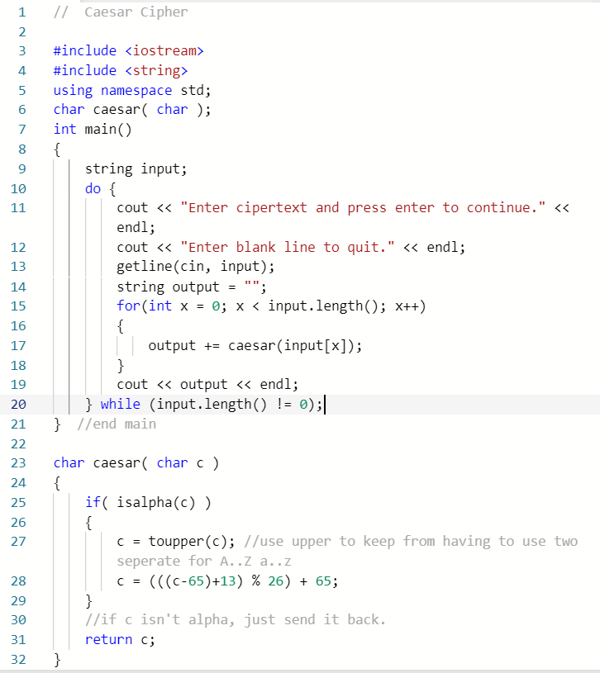
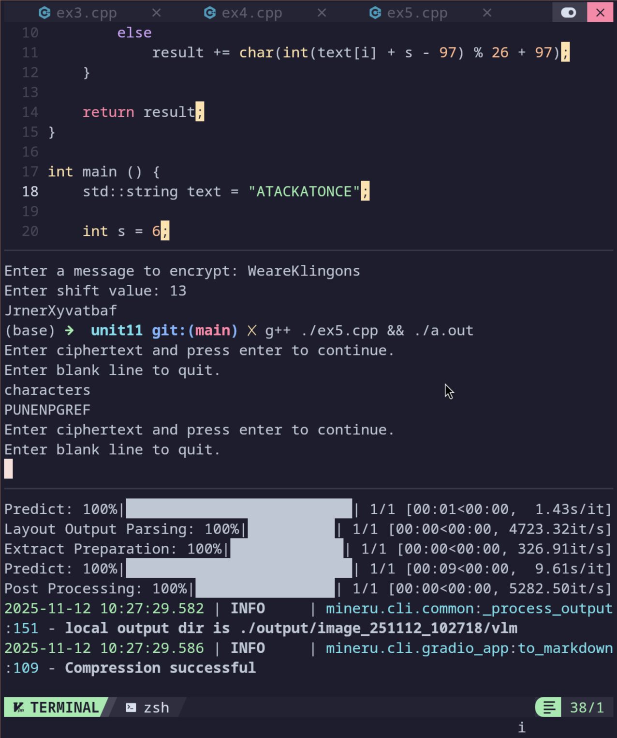
- Input the following program in IDE, run the program and answer the below questions:
- What is the shift value of the program? Does the program encrypt symbols and special characters?
No, only characters.
- Use shift cipher character substitution method to verify whether the program output for message: ‘characters’ is accurate.
punenpgref
- Review the program to identify the section that contains the primary functionality of shift cipher. Explain how the shift cipher is integrated in this program.
The caesar function does the encoding, it is very similar to example 1, but it just rejects any non alphabetic input and converts everything to upper case.
- Compare this program to Example 4 program, what are the differences and similarities in these shift cipher programs? Evaluate these programs based on complexity, efficiency, performance and accuracy.
This one isn’t as fast as example 4, but it is perfectly accurate whilst maintaining essentially the same speed.

Login Canvas and submit lab document that contains screen captures, question and answers.

